WORLD SHUAI JIAO GAMES 2026

Athlete Registration Procedure for Federations
All federations wishing to participate in the WSJG 2026 must complete the registration procedure described below.

1. Athlete Registration Form
Federations are required to download and complete the official Excel registration file provided by the organizers.
In the Excel file, each athlete must be entered on a separate line with the following information:
- Athlete’s Name
- Athlete’s Surname
- Sex*
- Age Category*
- Age Sub-Group*
- Weight Category*
*: in the Excel table, these categories require you to SELECT options from a dropdown window. DO NOT type the athletes’ categories in the table cells.
Example:
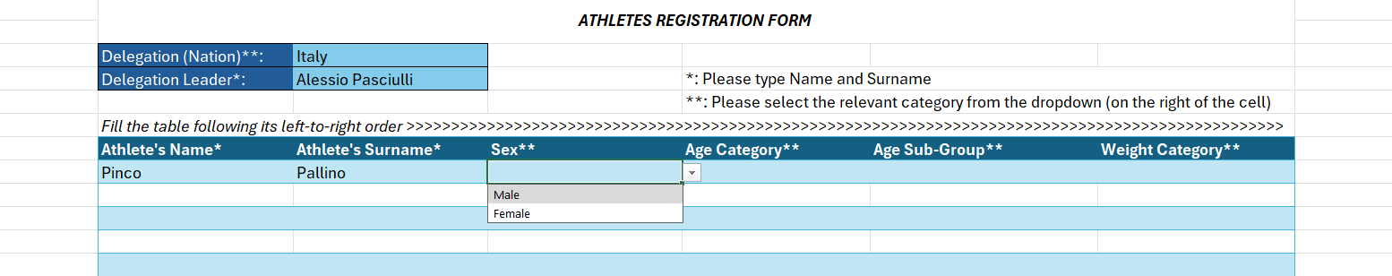
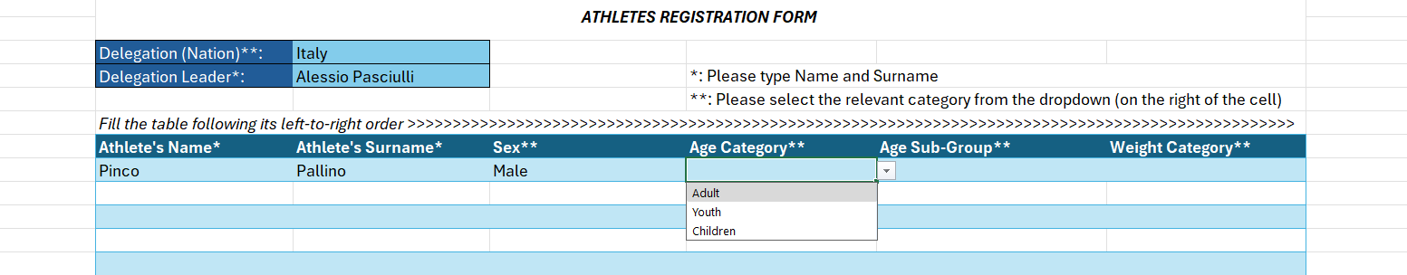
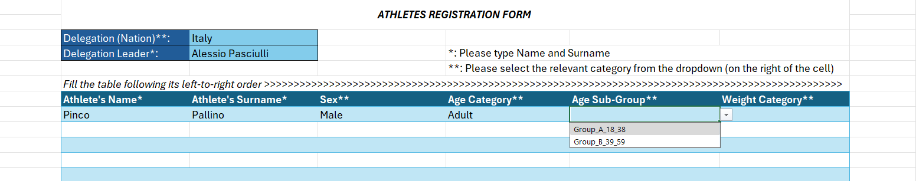
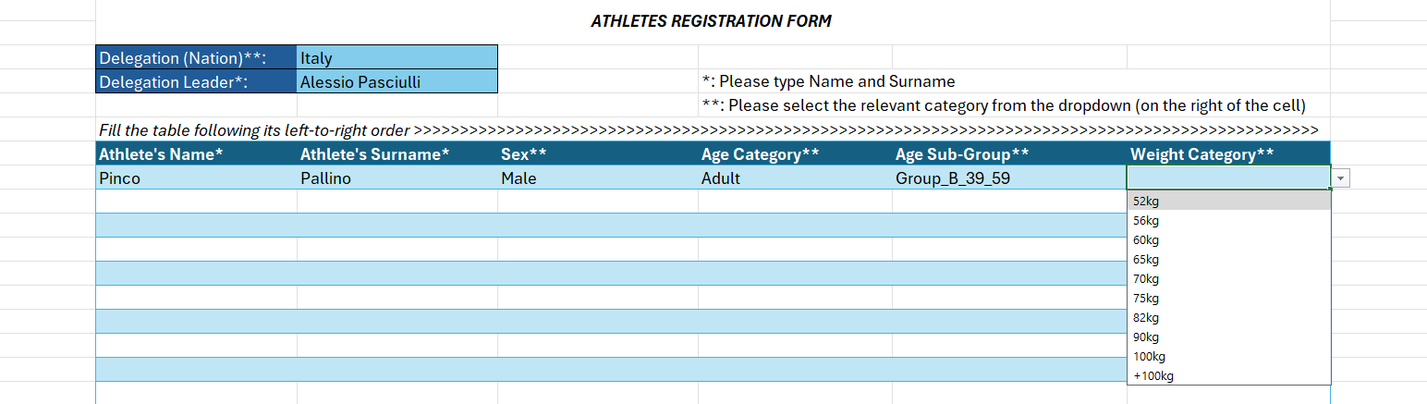

2. Sending the Registration
After completing the Excel file, federations must send the following documents by email to:
wsjg2026@acsi.it
The email must include:
- The completed Excel registration form (see section 1 above)
- Proof of payment of the registration fee (see section 3, 4 and 5 below)
- Accommodation request (see section 6 below)

3. Registration Deadlines
Adult and Youth categories
Registration deadline: 31 August 2026
Children categories
Registration deadline: 10 September 2026

4. Registration Fees

Adult and Youth Categories
- 01 March – 31 May: €60 per athlete
- 01 June – 30 June: €70 per athlete
- 01 July – 31 July: €80 per athlete
- 01 August – 31 August: €90 per athlete

Children Categories
- Until 10 September: €35 per athlete

5. Payment Details
Payment must be made via bank transfer to:
ACSI Associazione di Cultura Sport e Tempo Libero
Via Ostiense, 160/E
00154 Roma (RM) – Italy
IBAN: IT50S0306909606100000076397
BIC/SWIFT: BCITITMM
Bank: Intesa Sanpaolo
Via Colonna Antonina, 39
00186 Roma – Italy
Reason for payment:
WSG 2026 – [Society Name] – [Number of athletes]

6. Accommodation Request
In the same email, federations must also indicate the number and type of rooms required, together with the dates of stay.
Please specify clearly:
- Number of single rooms
- Number of double rooms
- Number of triple rooms
- Arrival and departure dates
Example:
3 double rooms from 9 October to 11 October
1 double room from 8 October to 10 October
1 single room from 9 October to 11 October

For any further information, federations may contact the organizing committee at:
wsjg2026@acsi.it

